Wave Basics

Name _______________________________

Use the PhET simulator, “Wave on a String” for the following questions. https://phet.colorado.edu/en/simulation/wave-on-a-string

- Are you familiar with longitudinal and transverse waves? Which type of wave is being shown by this simulator?

- Use arrows, or draw on the wave, to show what will happen when the amplitude is increased:

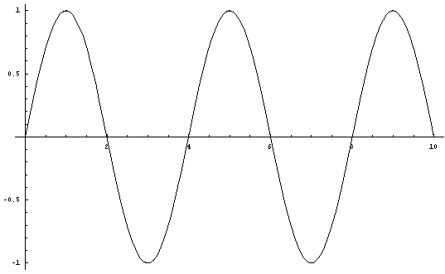

- Use arrows, or draw on the wave, to show what will happen when the frequency is increased:

- What direction does each individual part of the string move when a wave travels along it?

- What direction does the actual wave move (hint: try pulse)?

- The speed of the wave is how fast it travels from the oscillator (wrench) to the clamp/window/loose end. Does the speed vary depending on Amplitude, Frequency, damping, or tension? Make a table showing how/if it changes with each.

