Musical Instruments: Part 2

Name _______________________________

Learning Goals:
- Students will be able to describe how string instruments require a source of vibration and a resonance chamber (or sympathetic vibration).
- Students will be able to define frequency and vibration in terms of a sound wave and what we hear.
- Vocalizing and music both take vibration and a resonance chamber.

Your Voice
Hold your fingers against the front of your throat and say “aaaaah.” Notice the vibration against your fingers.

- Change the sound to “oooooh.” What do you notice with your fingers as you listen? What about your mouth?

- Change the sound to “eeeeee.” What do you notice with your fingers as you listen? What about your mouth?

- Would you say that different vowels are made differently by your throat or your mouth?

- Not say “ssssss,” NOT “Esssss.” Does your throat vibrate? What is vibrating?

- Make the sound “ffffff.” What is vibrating?

- Hold your hand to your throat while speaking. Pitch varies with emphasis given to different words and according to what your trying to say. The last words of question, for example, are at a higher pitch than the words at the beginning of the question.

String Instrument

- Tie a 3-foot piece of string to a table leg. Pull it tight and pluck it. Does it make a sound? Would you say it is a musical sound? What does it sound like to you?

- What if you slide the string between your thumb and index finger? Does it make a sound? Is it quiet or loud? How would you describe the sound?

Cup Instrument
You will need:
- plastic cup
- string
- paper clip
- scissors
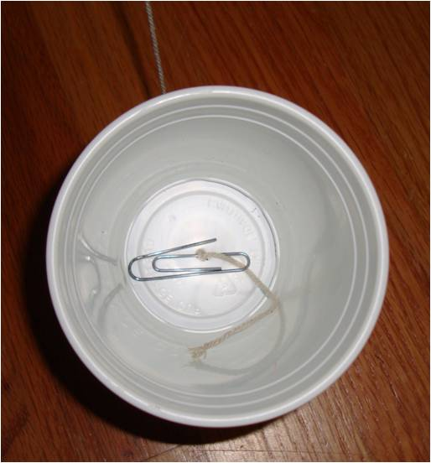
Take the cup and carefully poke a hole in the bottom with a pair of scissors. Put the string through the hole from the bottom of the cup and then tie the end of the string that is inside the cup to the paperclip. Pull all the extra string out of the bottom of the cup so that the paperclip touches the inside of the bottom of the cup.

- Hold the Cup so the string is loose and slide the string between your thumb and index finger. How does the sound compare to what you heard with just the string and NO cup?

- Does this change in volume remind you of the sympathetic vibration of the table tob when you placed a vibrating tuning fork on it?

- Now attach the string of your cup to a table leg. Pull the cup so that the string pulls very tightly against the table leg. Pluck the string. Can you get a musical (ish) sound from it?
- Have your partner hold the string at different lengths from the cup (still tied to the table leg!) while you pluck it. How does the sound change?

- How can you make it louder?

- What instrument does this remind you of?

- Can you summarize three important features of your cup instrument that makes it play sound, makes it loud and changes the pitch?

- How about your straw instrument from the previous activity? What were the three important features to make it play sound, make it loud and change the pitch?

- Get a wet paper towel and pinch the string very tightly as you slide the towel down it. If you do it right, you’ll get a very loud sound. What instrument does this remind you of?

- What is creating the vibration in this case?

Compare Cups

- find at least two other groups that have different cups that you used, but have the same string as you. How do their cup sounds compare to yours? what seems to be the cause of the difference, if there is any?

- Find one other group that has the same cup, but has different string than you. How does their cup sound compared to yours? What seems to be the difference, if there is any?

- When playing your cup instrument, did you hear any sounds that sounded like animals? What sound like what? Try to make a chicken noise (quick short slides) or a whale sound (long smooth slides).

Electric vs. Acoustic Guitars

- Compare the two types of guitars. Pluck a string on each one and compare the sounds.

- Why is the acoustic guitar so much louder? What is the difference between the two that causes the acoustic guitar to be loud?

- What happens if you press your finger on the string on one of the frets along the neck of the guitar? what happens if you hold the string down closer to the body (basically shortening the length of the string that can vibrate)?

- Name three string instruments that are “plucked” and three that use slip stick vibrations.

